EXP 16 : MATLAB SIMULATION OF SINGLE – BIT ERROR DETECTION AND CORRECTION USING SYNDROME VECTORS IN LINEAR BLOCK CODES

SOFTWARE USED : MATLAB SOFTWARE

CODE :
clc;
clear;
close all;

% Parity-check matrix for a (7,4) linear block code
H = [1 0 1 0 1 0 1;
0 1 1 0 0 1 1;
0 0 0 1 1 1 1];
% Original valid codeword
c = [1 0 1 1 0 0 1];
% Introduce a single-bit error at position 4
r = c;
r(4) = 1 - r(4);

% Calculate syndrome
s = mod(H * r', 2);

% Detect error position
pos = 0;
for i = 1:7
if isequal(H(:,i), s)
pos = i;
break;
end
end

% Correct the error
corrected = r;
if pos > 0
corrected(pos) = 1 - corrected(pos);
end

% Display results in Command Window
disp('SINGLE-BIT ERROR DETECTION AND CORRECTION');
disp('----------------------------------------');
disp(['Original Codeword : ', num2str(c)]);
disp(['Received Codeword : ', num2str(r)]);
disp(['Syndrome : ', num2str(s')]);

if pos > 0
fprintf('Error Position : %d\n', pos);
disp(['Corrected Codeword : ', num2str(corrected)]);
else
disp('No single-bit error detected.');
end

% Plot the results
figure('Name','Syndrome Error Correction','Color','w');

subplot(3,1,1);
stem(1:7,c,'filled','LineWidth',1.5);
title('Original Codeword');
xlabel('Bit Position');
ylabel('Bit Value');
xlim([0 8]); ylim([-0.2 1.2]);
grid on;

subplot(3,1,2);
stem(1:7,r,'filled','LineWidth',1.5);
title('Received Codeword (Error at Bit 4)');
xlabel('Bit Position');
ylabel('Bit Value');
xlim([0 8]); ylim([-0.2 1.2]);
grid on;

subplot(3,1,3);
stem(1:7,corrected,'filled','LineWidth',1.5);
title('Corrected Codeword');
xlabel('Bit Position');
ylabel('Bit Value');
xlim([0 8]); ylim([-0.2 1.2]);
grid on;

MODEL GRAPH :
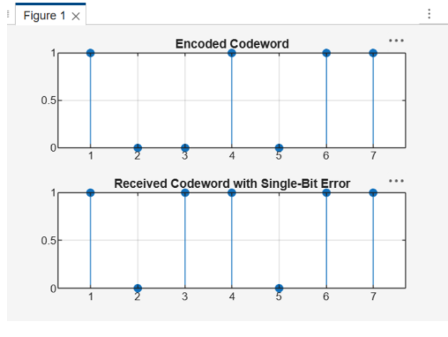
RESULT :
